**Практика.  
Прочтите требования и проанализируйте их:**

**Settings/Functions on the “Create View” Page**

* “Report View Name” → sets Report View displayname for the roles: FirmManager and Advisor.
* Text box
* Character limit = 255
* Validation: once user clicks outside of “Report View Name” textbox, validate display name character count <= 256
* If Fails validation, then display red border around text box
* Radio Icon “Report Type” component with options for Firm Report / Client Report → sets Report View context
* Radio Icon “Format” component with options for CSV / PDF/ XLS → sets Report View format
* Radio Icon “Orientation” component with options for Landscape/Portrait → sets Report View orientation
* IF Report View format = PDF, then show Orientation component only for FirmManager.
* Else hide Orientation component
* Button: “Create View”
* “Create View” is greyed out and not clickable unless:
* displayname is not null
* viewcontext is not null
* format is not null
* IF format = PDF, then orientation is null
* Upon click, attempts to create and save Report View object
* Save Validation: upon save, validate that display name must be unique within firm
* If Fails validation, then display red border around text box and prevent save
* Save Validation: upon save, validate that display name character count <=255
* If Fails validation, then display red border around text box and display message:
* Upon successful save by clicking Save button, takes you to Report Builder Page.

User stories

* + As a Firm Manager I want to open Create View page, click on Report Type button and download report in PDF format.
  + As a Client I want to open Create View page, click on Create View button and save report file
  + As a Client I want to click Create View button, save report and move to Report builder Page.

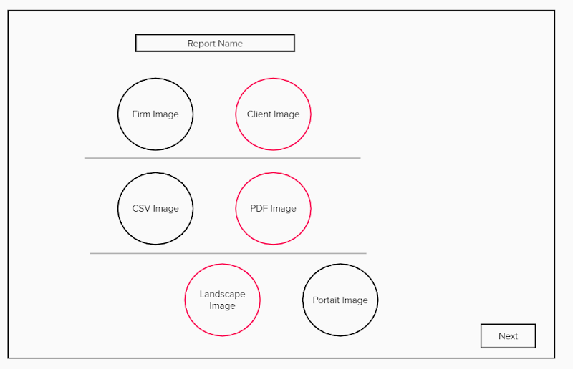  
  
  
**Это был пример пользовательских требований к New Feature.**

**А теперь Задания:**  
1. Найдите ошибки в требованиях и нестыковки с дизайном.

2. Напишите минимум 3 User stories, исходя из представленных требований, опираясь на следующий формат:  
**Как, <роль/персонаж юзера>, я <что-то хочу получить>, <с такой-то целью> .**

**Пример: As a FirmManager I want to open  “Create View” Page, click on “Report View Name” field, so that I can input text in it.  
  
  
Формат сдачи ДЗ свободный, без шаблона. Загрузите доки в github, ссылки на github скидывайте прямо в чат (только проследите, что вы даете доступ к просмотру вашего документа).  
Дедлайн(Deadline): 23:59 pm 4 октября ВТ.**

**Repositories:QAM05  
File naming: Meaningful part + (hw_1). Example “Requirements Analysis(hw_1)”**